Department of CSE-IOT

Vision of the Department
To be a preferred hub for nurturing computer engineering aspirants through innovative, ethical, value-based technical education, impactful research, and industry collaboration, to become successful professionals contributing for the betterment of society.

Mission of the Department
To nurture computer engineering professionals by offering: Dynamic learning environment that encourages problem-solving using emerging technology, · National Education Policy aligned evidence-based technical education, fostering innovation, research, and industry–institute
collaboration, Holistic, ethical and sustainable development for lifelong success.

Session 2025-2026(EVEN)
Mission: Means to achieve Vision
Vision: Dream of where you want.
Program Educational Objectives of the program (PEO): (broad statements that describe the professional and career accomplishments)
PEO1 | Preparation | P: Preparation | Pep-CL abbreviation  pronounce as Pep-si-lL easy to recall
PEO2 | Core Competence | E: Environment (Learning Environment)
PEO3 | Breadth | P: Professionalism
PEO4 | Professionalism | C: Core Competence
PEO5 | Learning  Environment | L: Breadth (Learning in diverse areas)

Program Outcomes (PO): (statements that describe what a student should be able to do and know by the end of a program)

Keywords of POs:
Engineering knowledge, Problem analysis, Design/development of solutions, Conduct Investigations of Complex Problems, Engineering Tool Usage, The Engineer and The World, Ethics, Individual and Collaborative Team work, Communication, Project Management and Finance, Life-Long Learning

PSO Keywords: Cutting edge technologies, Research

“I am an engineer, and I know how to apply engineering knowledge to investigate, analyse and design solutions to complex problems using tools for entire world following all ethics in a collaborative way with proper management skills throughout my life.” to contribute to the development of cutting-edge technologies and Research.

Integrity: I will adhere to the Laboratory Code of Conduct and ethics in its entirety.

Anushka Yede

06-03-2026

Name and Signature of Student and Date
(Signature and Date in Handwritten)

Department of CSE-IOT

Vision of the Department
To be a preferred hub for nurturing computer engineering aspirants through innovative, ethical, value-based technical education, impactful research, and industry collaboration, to become successful professionals contributing for the betterment of society.

Mission of the Department
To nurture computer engineering professionals by offering: Dynamic learning environment that encourages problem-solving using emerging technology, · National Education Policy aligned evidence-based technical education, fostering innovation, research, and industry–institute
collaboration, Holistic, ethical and sustainable development for lifelong success.

Session | 2024-25 (EVEN) | Course Name | Mobile and Web Application for IOT Lab
Semest er | 6 | Course Code | 23IOT1624
Roll No | 01 | Name of Student | Anushka Yede

Practical Number | 3
Course Outcome | - Understand and apply basic Kotlin programming constructs including variables, control structures, functions, null safety, and object-oriented concepts for Android app development.  - Design and develop responsive user interfaces using XML layout files, ViewGroups, and widgets in Android Studio, adhering to Material Design principles.  - Implement event handling and application logic using Kotlin to capture user input, manage app state, navigate between screens, and interact with Android system components like Toasts and Dialogs  - Integrate learned concepts to develop a mini Android application that demonstrates use of ViewModel, multi-screen navigation, and proper UI/UX design for real-world problem-solving
Aim | To understand and apply Kotlin collections and higher-order functions by working with lists, maps, and sets, and using lambda expressions along with functions such as filter, map, and forEach, as well as implementing custom higher-order functions to perform operations on collection data.
Problem Definitio  n | Work with Kotlin collections and higher-order functions. Tasks: Lists, maps, sets, lambdas, filter, map, forEach, custom higher-order functions.
Theory (100  words) | Kotlin provides powerful collection types to store and manage groups of data efficiently. The main collection types are List, Set, and Map. A List is an ordered collection that allows duplicate elements and elements can be accessed using their index. A Set is a collection that stores only unique elements and does not allow

Department of CSE-IOT

Vision of the Department
To be a preferred hub for nurturing computer engineering aspirants through innovative, ethical, value-based technical education, impactful research, and industry collaboration, to become successful professionals contributing for the betterment of society.

Mission of the Department
To nurture computer engineering professionals by offering: Dynamic learning environment that encourages problem-solving using emerging technology, · National Education Policy aligned evidence-based technical education, fostering innovation, research, and industry–institute
collaboration, Holistic, ethical and sustainable development for lifelong success.

duplicates. A Map stores data in key–value pairs, where each key is unique and maps to a specific value.

Kotlin also supports lambda expressions, which are short anonymous functions used to perform operations in a concise way. These lambdas are commonly used with higher-order functions, which are functions that take other functions as parameters or return functions.

Common higher-order functions used with collections include filter(), map(), and forEach(). The filter() function selects elements based on a condition, map() transforms elements, and forEach() performs an action on each element. These features make Kotlin code more readable, flexible, and efficient.
Procedur e and Executio n | Step for Implementation:  Open IntelliJ IDEA / Android Studio and create a new Kotlin project.
 | Create a Kotlin file named Main.kt in the project.
(100  Words) | Define a higher-order function gradeCalculator() that accepts marks and grading logic as a lambda function.
 | In the main() function, create a Map collection studentMarks to store student names
 | and their marks.
 | Use the forEach() function to display all students and their marks.
 | Apply the filter() function to select students who scored 60 or above.
 | Use mapValues() to add grace marks (+5) to the filtered students.
 | Display the updated marks using forEach().
 | Use a lambda expression with when condition inside gradeCalculator() to assign
 | grades (A, B, C, Fail).

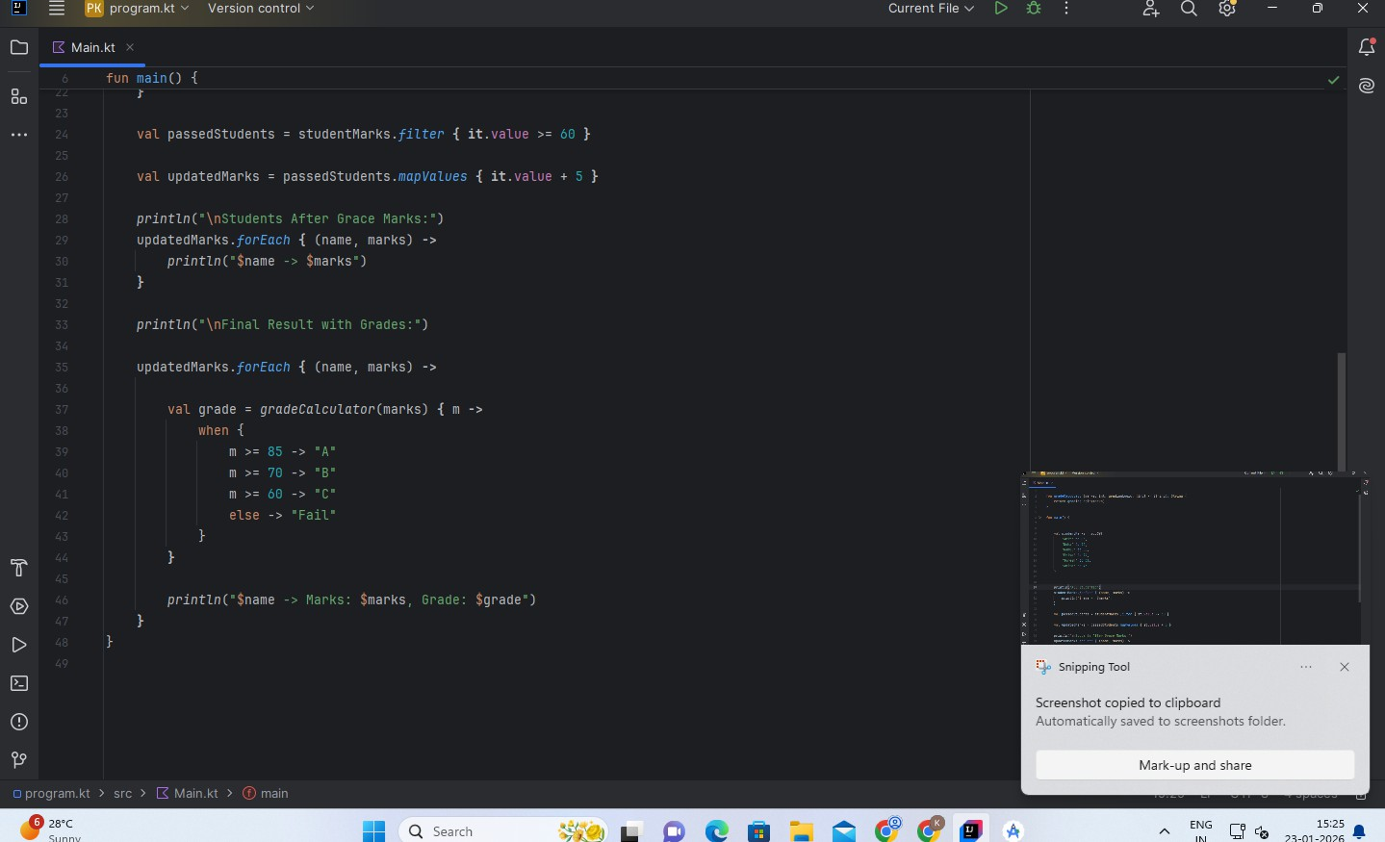
Department of CSE-IOT

Vision of the Department
To be a preferred hub for nurturing computer engineering aspirants through innovative, ethical, value-based technical education, impactful research, and industry collaboration, to become successful professionals contributing for the betterment of society.

Mission of the Department
To nurture computer engineering professionals by offering: Dynamic learning environment that encourages problem-solving using emerging technology, · National Education Policy aligned evidence-based technical education, fostering innovation, research, and industry–institute
collaboration, Holistic, ethical and sustainable development for lifelong success.

Print the final result with marks and grades.
Run the program and verify the output in the console.
Code:

Department of CSE-IOT

Vision of the Department
To be a preferred hub for nurturing computer engineering aspirants through innovative, ethical, value-based technical education, impactful research, and industry collaboration, to become successful professionals contributing for the betterment of society.

Mission of the Department
To nurture computer engineering professionals by offering: Dynamic learning environment that encourages problem-solving using emerging technology, · National Education Policy aligned evidence-based technical education, fostering innovation, research, and industry–institute
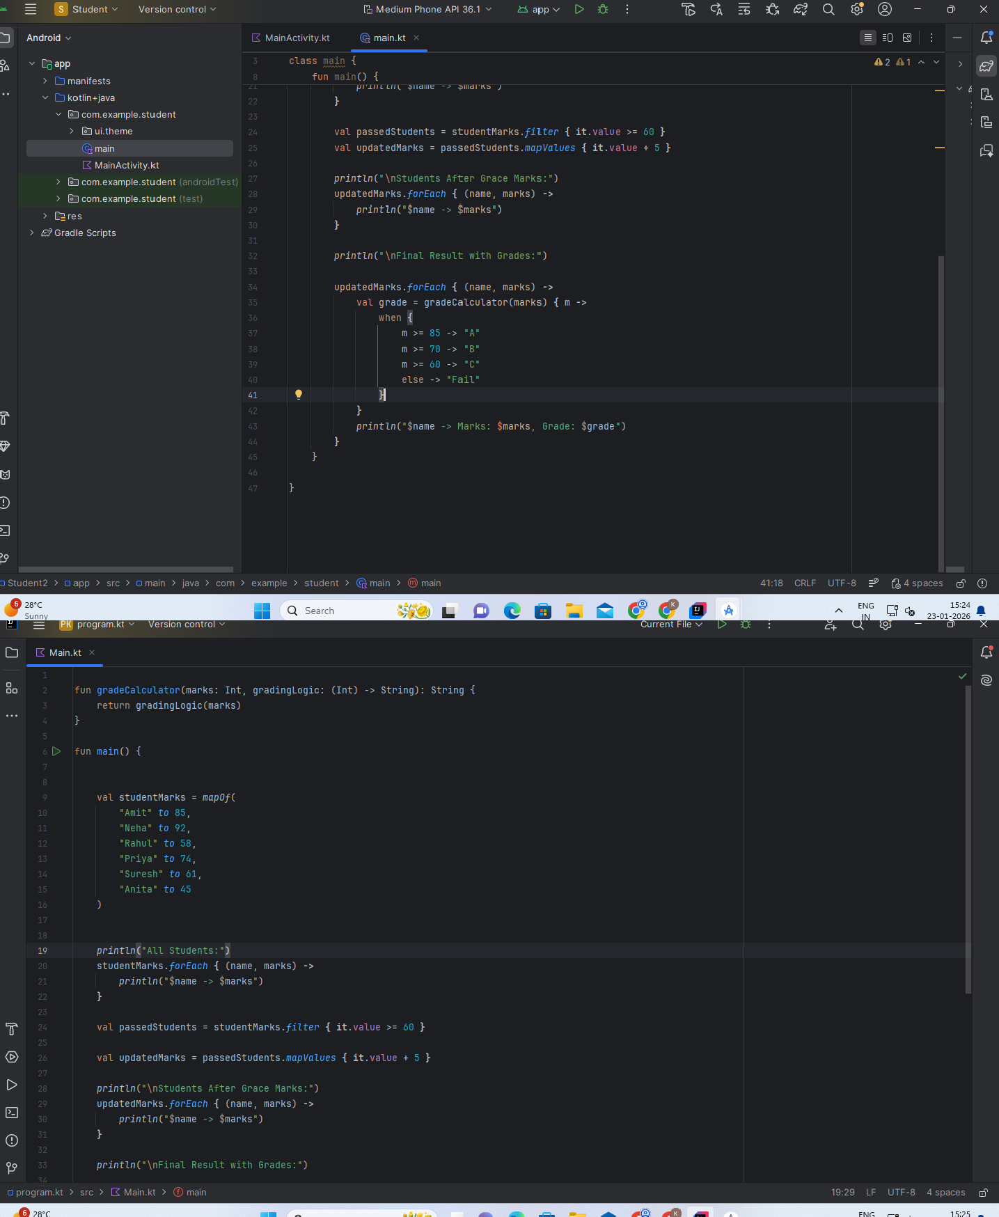
collaboration, Holistic, ethical and sustainable development for lifelong success.

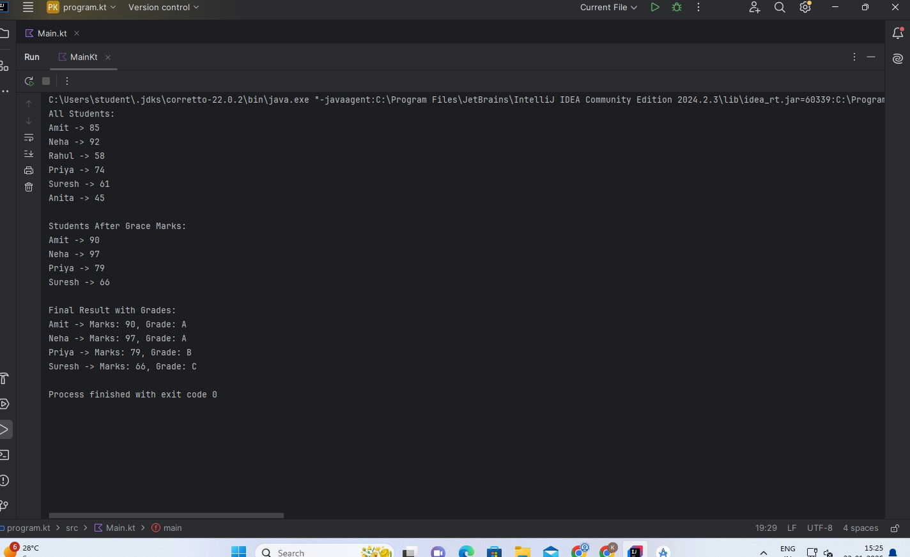
Department of CSE-IOT

Vision of the Department
To be a preferred hub for nurturing computer engineering aspirants through innovative, ethical, value-based technical education, impactful research, and industry collaboration, to become successful professionals contributing for the betterment of society.

Mission of the Department
To nurture computer engineering professionals by offering: Dynamic learning environment that encourages problem-solving using emerging technology, · National Education Policy aligned evidence-based technical education, fostering innovation, research, and industry–institute
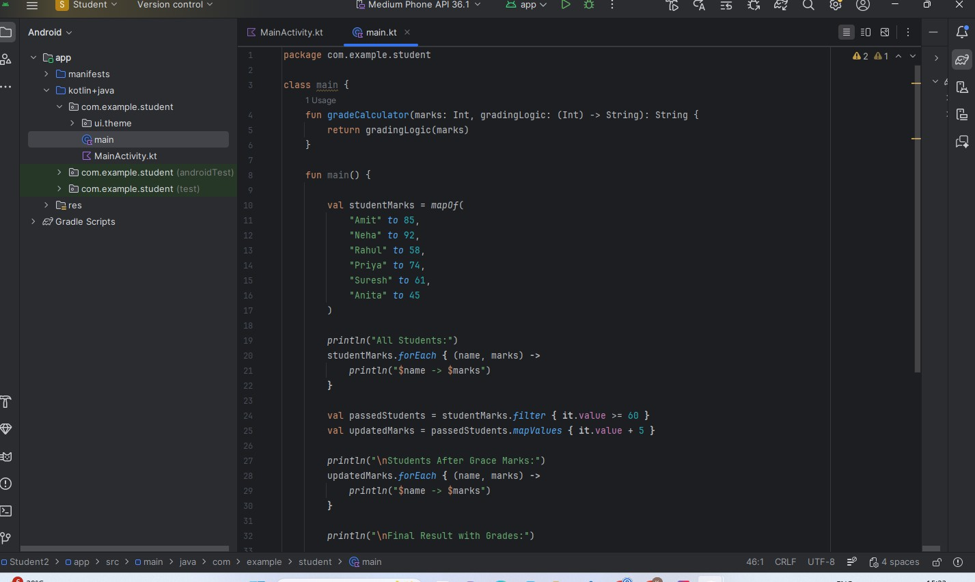
collaboration, Holistic, ethical and sustainable development for lifelong success.

Output:

Department of CSE-IOT

Vision of the Department
To be a preferred hub for nurturing computer engineering aspirants through innovative, ethical, value-based technical education, impactful research, and industry collaboration, to become successful professionals contributing for the betterment of society.

Mission of the Department
To nurture computer engineering professionals by offering: Dynamic learning environment that encourages problem-solving using emerging technology, · National Education Policy aligned evidence-based technical education, fostering innovation, research, and industry–institute
collaboration, Holistic, ethical and sustainable development for lifelong success.

Output Analysis | The program filters students scoring above 60, adds grace marks, calculates grades using lambda functions, and displays updated marks with grades.
Link of student Github profile  where lab assignme nt has been uploaded | https://github.com/23071016/MWIOT-.git
Conclusi on | Program executed successfully.
Plag Report (Similarit y index < 12%) | 

Department of CSE-IOT

Vision of the Department
To be a preferred hub for nurturing computer engineering aspirants through innovative, ethical, value-based technical education, impactful research, and industry collaboration, to become successful professionals contributing for the betterment of society.

Mission of the Department
To nurture computer engineering professionals by offering: Dynamic learning environment that encourages problem-solving using emerging technology, · National Education Policy aligned evidence-based technical education, fostering innovation, research, and industry–institute
collaboration, Holistic, ethical and sustainable development for lifelong success.

Date | 4/2/2026

